VOI App User Manual:

## Introduction:

The VOI app serves as an open-source tool for computing value of information for geological datasets in geothermal project development. VOI is a decision theoretical concept that originates from decision analysis. The basic premise of VOI is that acquiring information when presented with a decision having several alternatives could result in a change in the initial decision. The ‘value’ generated by this change in decision is the value of information. Conventionally, VOI can be of two types- Value of Perfect Information (Assuming the information is perfect i.e. provides a complete picture of what we are trying to model) and Value of Imperfect Information. Most, if not all, geological data is imperfect, and thus the goal of this app is to provide a straightforward environment for computing the value of this imperfect information.

## Deciphering the Demo Problem:

The VOI app includes an example problem at the very beginning, highlighting the various terminologies used in the app, and introducing the user to basic terms in Bayesian Statistics. It also covers a brief overview of how the main VOI app calculations work.

Figure 1: Inputs for demo problem: left arrow: prior probability of success (geothermal resource exists) and right arrow: economic outcome when geothermal resource exists when you do nothing or take action (e.g. drill, vdrill(Success))

In the Figure 1 above, the two ‘toggles’ the user can change are indicated by the blue arrows. The prior probability of success (*Pr(Positive)*, ranging from 0-1) and the positive (economic) outcome of a successful well (integer values) can be modified to observe how this changes the prior value (Vprior) and the Value of Perfect Information (VOIperfect). A range of negative values, i.e. unsuccessful outcome, are assigned to match the drilling cost per well for each depth from the open-source tool GEOPHIRES-X. They are displayed on the x-axis in Figure 2.

As shown in the App, the Vprior is the action that has the highest (weighted) average, using the prior probability as the weights:

Vprior = max(Va=drill, Va=walk away), where,

* Va=drill = Pr(Positive) * vdrill(Positive) + (1-Pr(Positive)) * vdrill(Negative)
* Va=walk away = Pr(Positive) * vwalk away(Positive) + (1-Pr(Positive)) * vwalk away(Negative)

In the demo example, when Vprior = $0, it says the best (highest) action is to walk away (don’t drill). The risk (probability * outcome) of drilling is too high.

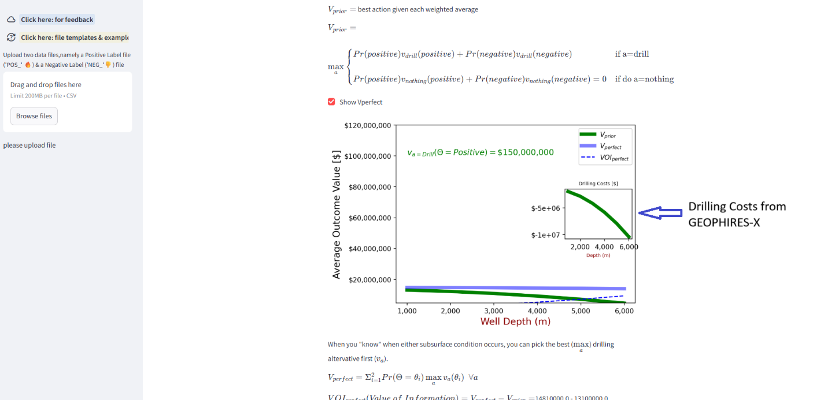

Figure 2: Visualization of Demo Problem in app as a function of drilling costs (x-axis). The plot shows prior value (Vprior green), value with perfect information (Vperfect, solid blue) and value of perfect information (VOIperfect, dashed blue).

The Vperfect (the value with perfect information) is an upper bound on the maximum value that the information can have: it assumes a hypothetical information source can perfectly reveal if the geothermal resource exists or not. It is dependent on the prior probability chosen. In our demo problem, we assume the positive outcome remains the same across all depths, while the drilling costs increase as we go deeper. Compared to Vprior, Vperfect swaps the order of the max and weighted average operations: this mimics how the perfect information source will allow us to choose the best (max) action for each scenario (positive and negative), before averaging.

$V_{perfect}=P\left(Positive\right)*V\left(Positive\right)+\left(1-P\left(Positive\right)\right)*V(Negative)$, where,

* V(Positive) = max(vdrill(Positive), vwalk away(Positive))
* V(Negative) = max(vdrill(Negative), vwalk away(Negative))

The value *of* perfect information (VOIperfect) compares how much of Vimperfect is higher than Vprior: VOIperfect = Vperfect - Vprior. As shown in Figure 2, VOIperfect has the most value when the drilling costs are highest and Vprior is lowest.

## Dataset Uploading:

The next part of the VOI App allows users to upload their own datasets. The App does not store the data, so users can upload proprietary data without jeopardizing any business sensitivities.

The input dataset must be created in a specific format to ensure that the app can read in the data. The steps to generate such a dataset are the following:

1. Two files must be uploaded, one containing data that is from a ‘positive’ label with the prefix ‘POS’ (POS_*filename*), and another that is from a ‘negative’ label with prefix ‘NEG’ (NEG_*filename*). These labels can be defined by the user and need not coincide with actual geothermal sites. For example, they could be generated synthetic data from forward modeling.
2. Each of the files must contain at a minimum two columns representing feature of interest and a distance to positive labels if a positive file (‘PosSite_Distance’) and distance to negative label if a negative file (‘NegSite_Distance’).
3. When these files are ready, a csv version must be uploaded onto the app (Figure below for reference).

Figure 3 demonstrates how files are uploaded on the left side of the App. The example files are from the Walker Lane section of the INGENIOUS project[1] (located in the GitHub repository[2]). They display the correct naming terminology as mentioned above. The files must contain a distance column for the app to work (see the file template for more details), and the slider in the figure can be adjusted to include/exclude more points. The default value for the slider is the Q1 distance taken from the negative label file.

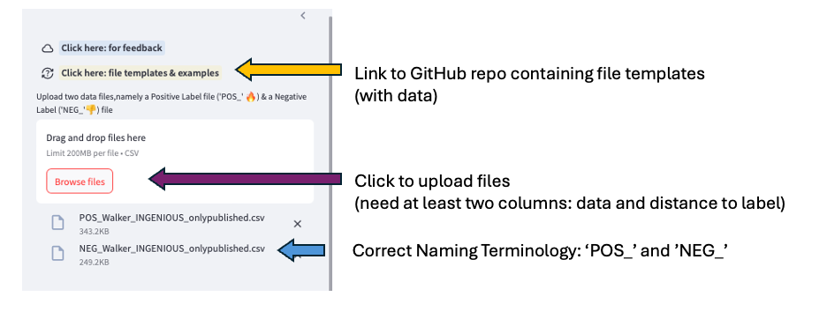

Figure 3: Upload function of where to labeled data files are loaded in VOI App

Once the files have been uploaded, the user has the choice to select two options for in-built project economics based on the open-source tool GEOPHIRES-X. These options are end use options for *electricity* or *direct use* (top blue arrow of Figure 4)*.* The default values for electricity costs are taken from the recent Fervo PPA ([Fervo PPA](https://gtp.scientificwebservices.com/geophires/)) and general default values are available on the GEOPHIRES-X GitHub page ([GEOPHIRES-X defaults](https://github.com/NREL/GEOPHIRES-X)). If more than one data feature is in the files (as is the case for the example files on the VOI App Github), the bottom purple arrow of Figure 4 allows the user to choose between them. The plot is the likelihood from the raw data values: the green from the positive file and the red from the negative file. The user can also screen data values far from the label. The slider shown with the blue arrow chooses this cutoff distance: a larger screening distance includes more points in the likelihood (e.g. data features farther away from labels of a positive or negative geothermal resource).

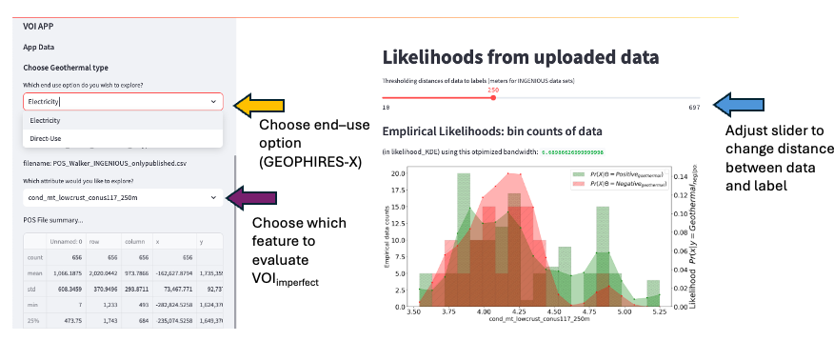

Figure 4 VOI App parameter selections: Top-yellow arrow) end use selection (electricity or heating), Middle-purple arrow) data feature selection, and right-blue arrow) distance threshold between data and the positive or negative label.

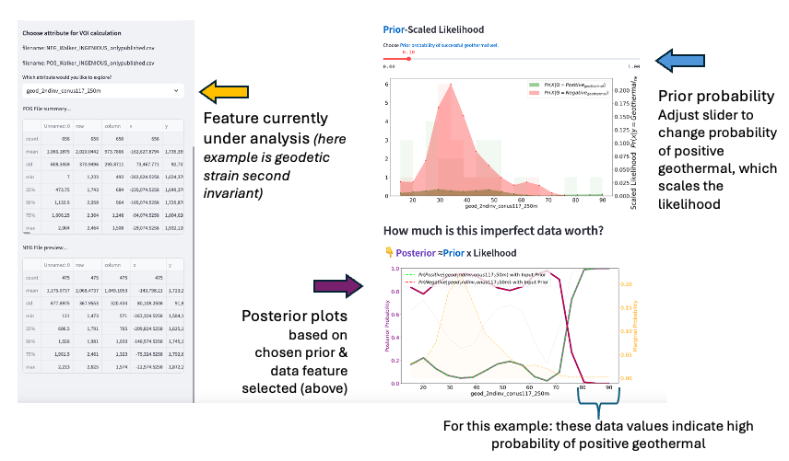

Figure 5: Scaled-likelihood and posterior plots for a given feature (example is from Walker Lane, second invariant strain).

Figure 5 provide a visual representation of the two probabilistic functions that are both a function of the prior probability on the labeled-data distributions: the likelihood and posterior. The top of Figure 5 has a plot of the scaled likelihood of the current feature from the uploaded file (blue arrow on right side of Figure 5) and the prior probability of a positive geothermal site. The bottom of Figure 5 presents the posterior plots for each data bin: the red for negative and green for positive geothermal. The green posterior indicates the probability of a geothermal resource occurring if that particular data value were observed. For the example shown, if the strain invariant is 55, there’s roughly a 20% probability a geothermal resource exists. However, if the strain invariant is > 80, there’s a very high probability for a positive geothermal resource. The marginal probability is plotted in orange and indicates the data density of the uploaded data file for each given histogram bin.

## VOI Metrics:

Once an end use option has been selected, the user can input the temperature gradient and depth to the reservoir as shown in Figure 6 (blue and yellow arrows, respectively). GEOPHIRES-X is then run, and the corresponding project NPV is populated in the ‘*Geothermal Resource (positive)’* column, and the drilling cost per well is populated in the ‘*No Geothermal Resource (negative)’* column. The first column refers to the outcome if the well is successful, and the second is if the well is unsuccessful. The NPV changes based on the end-use option selected, while the drilling cost remains the same, and only changes if the depth parameter is altered.

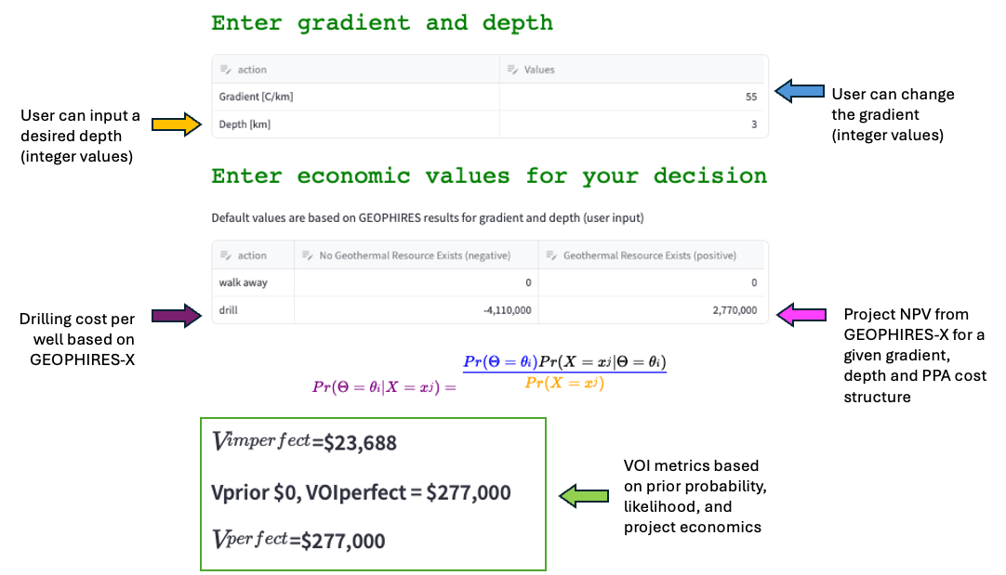

Figure 6 VOI app economics input parameters and output metrics.

The VOI App currently uses the same default parameters as would be used in a generic run of GEOPHIRES, with the exception of the following parameters:

"Economic Model": "3",

"Starting Electricity Sale Price": "0.15",

"Ending Electricity Sale Price": "1.00",

The BICYCLE economic model (in place the default standard levelized cost method) is “3”. The VOI App is defaulting to "Power Plant Type": "1", a subcritical ORC, and two injector ("Number of Production Wells") and two producer wells ("Number of Production Wells").

The parameters can be viewed in the file GEOPHIRES_X.py[3]. In theory, this is where parameters could be overwritten. However, this would have to be done on a local version of the code repository, then a local instance of the streamlit app would need to be run. The fastest way to implement different parameters (e.g. porosity, fractures characterization, etc.) is to run GEOPHIRES separately, get your costs and NPV, and then enter those into the value matrix (purple and pink arrows in Figure 6). The user is always able to input their own choices for project economics there.

Finally, for any feedback related to the app, users can click on the feedback form button on the top-left hand side of the app which will re-direct them to a Microsoft form.

1. https://gdr.openei.org/submissions/1391
2. https://github.com/NREL/Value_of_Information_App/tree/main/File Template
3. https://github.com/NREL/Value_of_Information_App/blob/main/GEOPHIRES_X.py